Part-1 Calculator
Introduction:
Developed a calculator application using React.js as front-end and Node.js as back-end. The purpose of the application is to perform the basic arithmetic calculations like addition, subtraction, multiplication and division. The calculations will be stored in the server and as per the statement of the user the calculations are performed.
System Design:
System consists of a client and a server.
Server:
- Build on Node JS framework
- Uses express JS web application framework
- IDE VSCode
Client:
- Built on React JS framework
- IDE VSCode

Calculator Homepage:
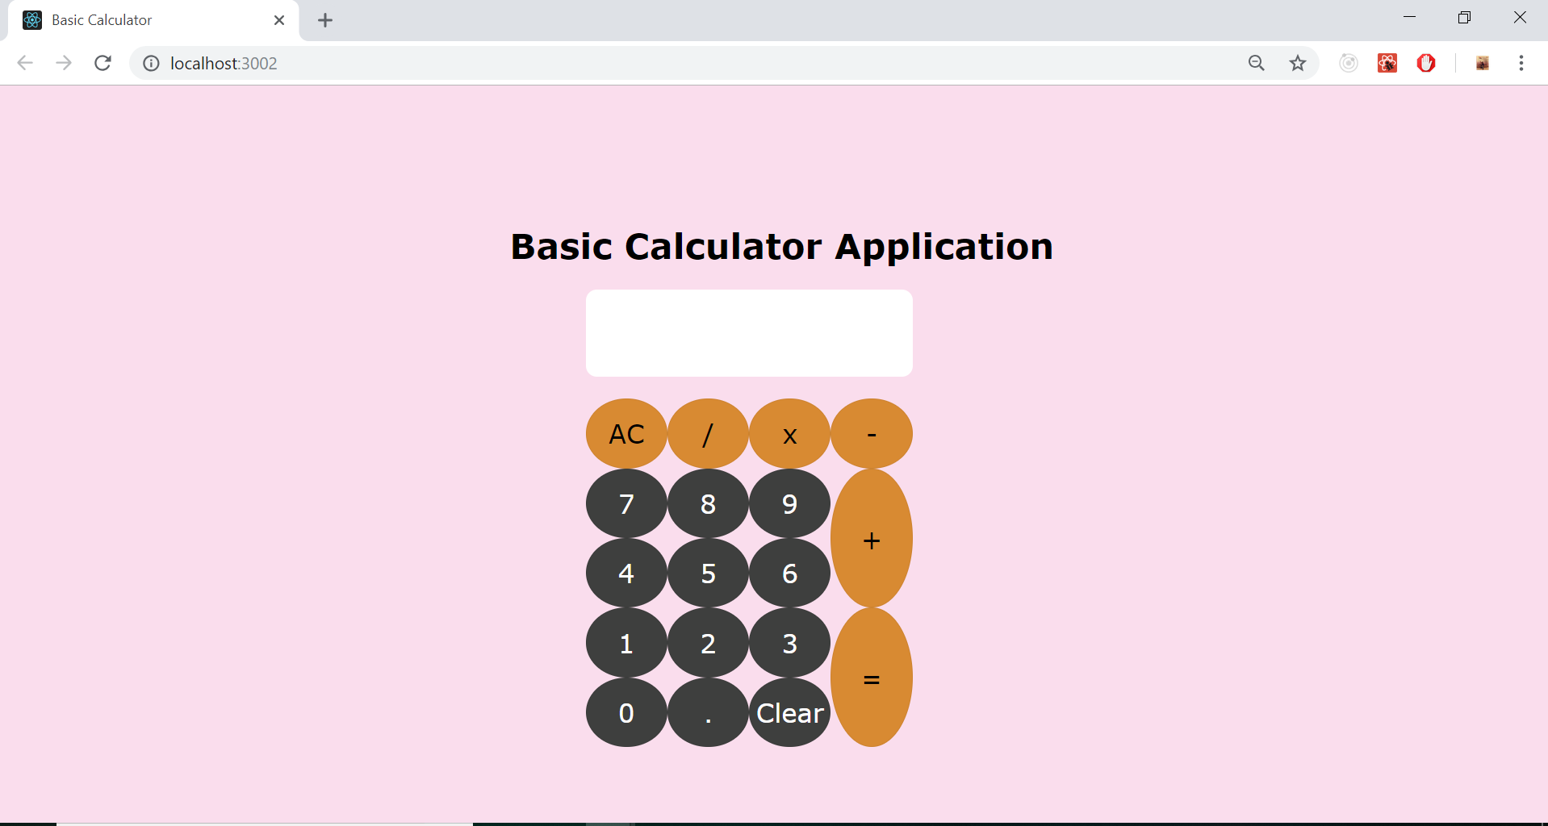

Writing equation to be solved:
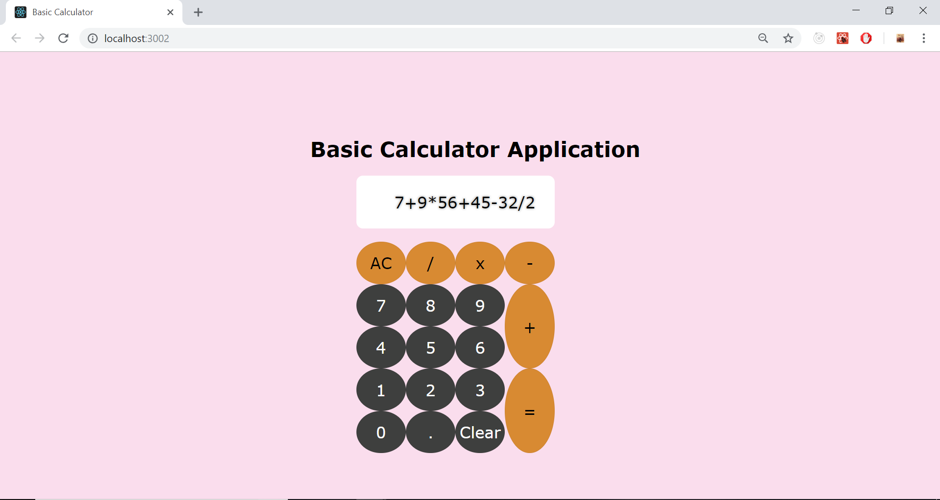
Answer to the statement input:
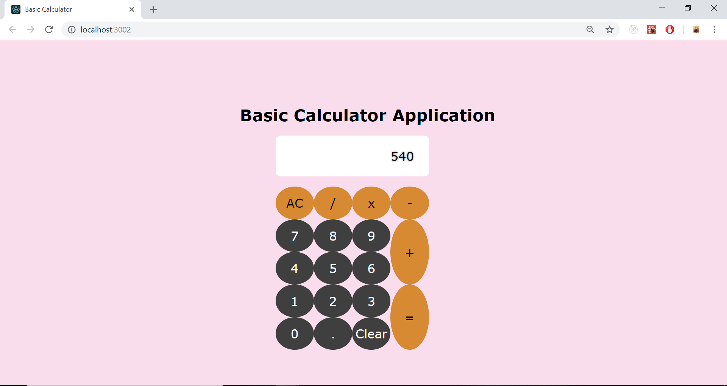

Console Output of the calculation performed:
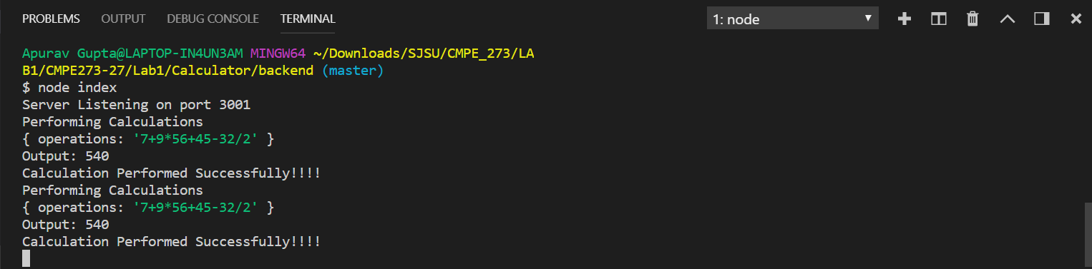
JMeter Testing of Calculator Application:
following report contains the data of run for 1 user 1000 request, 1 user 5000 request and 100 users 1000 each.
1 user 1000 requests
Graph Results:
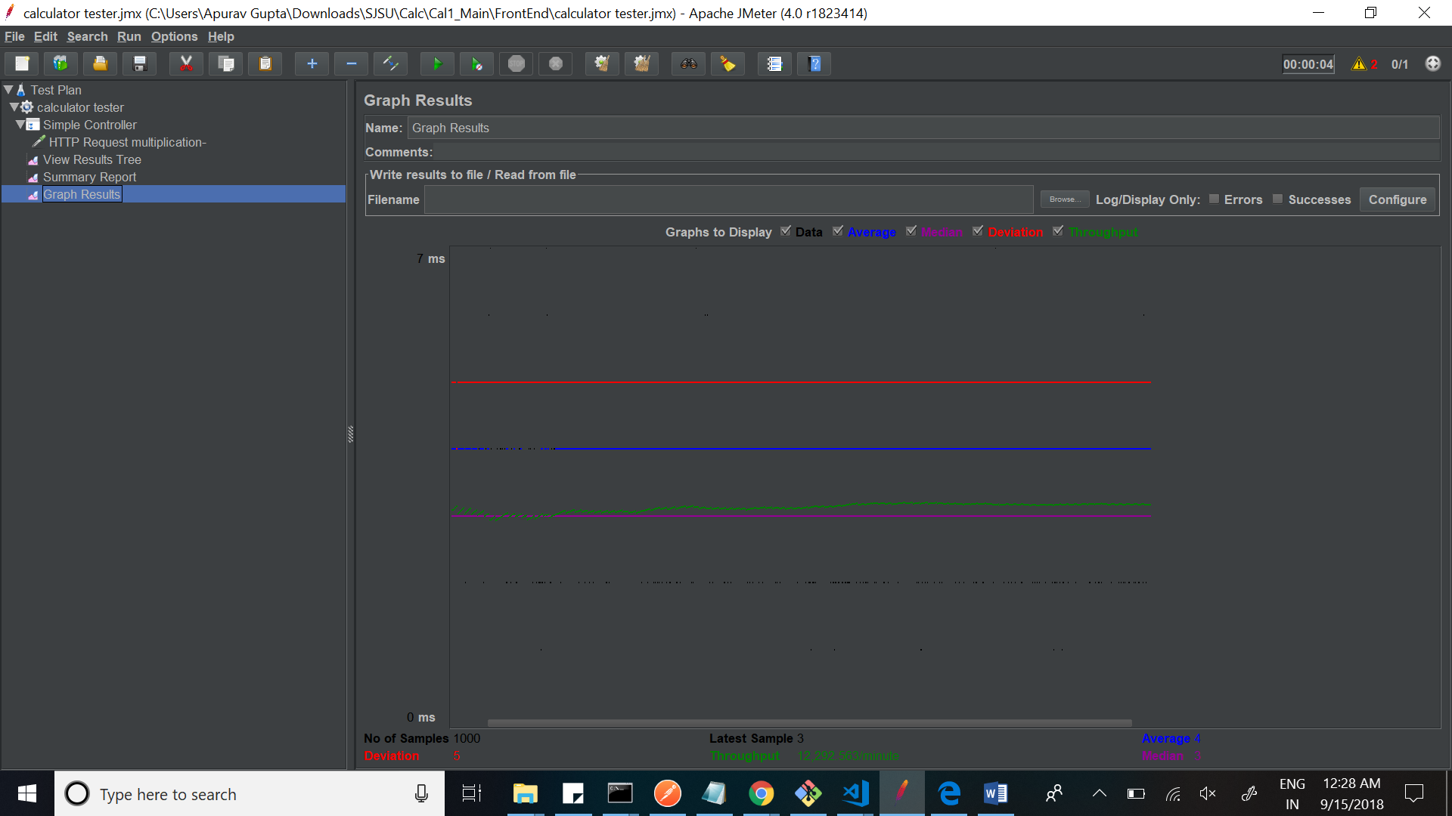

Average time with Deviation
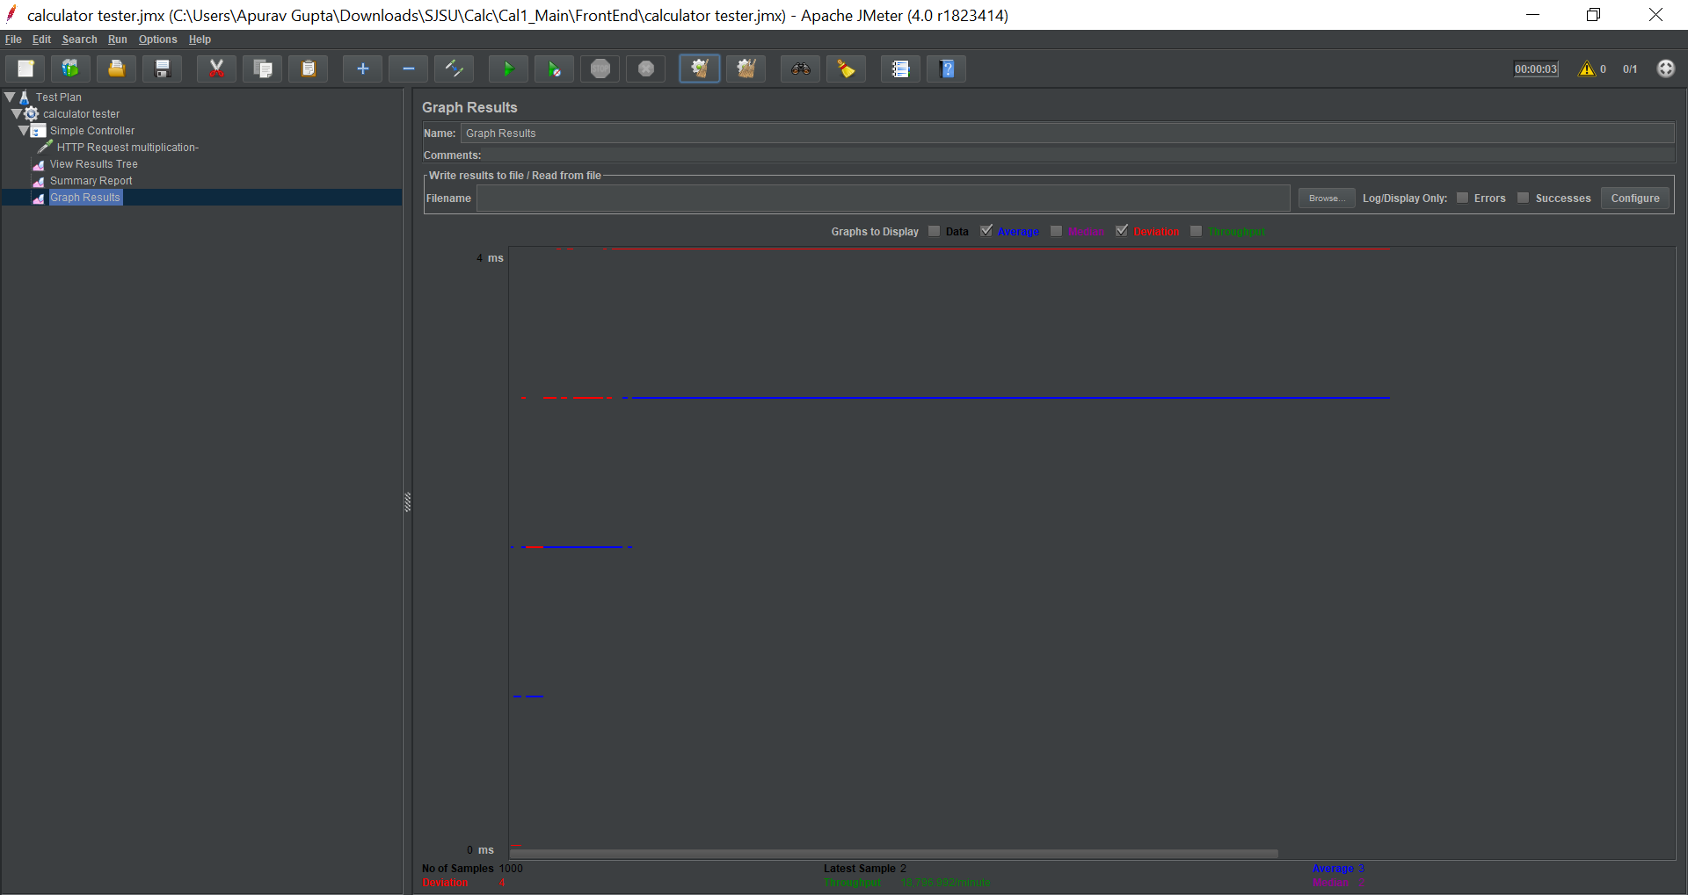
Average time:
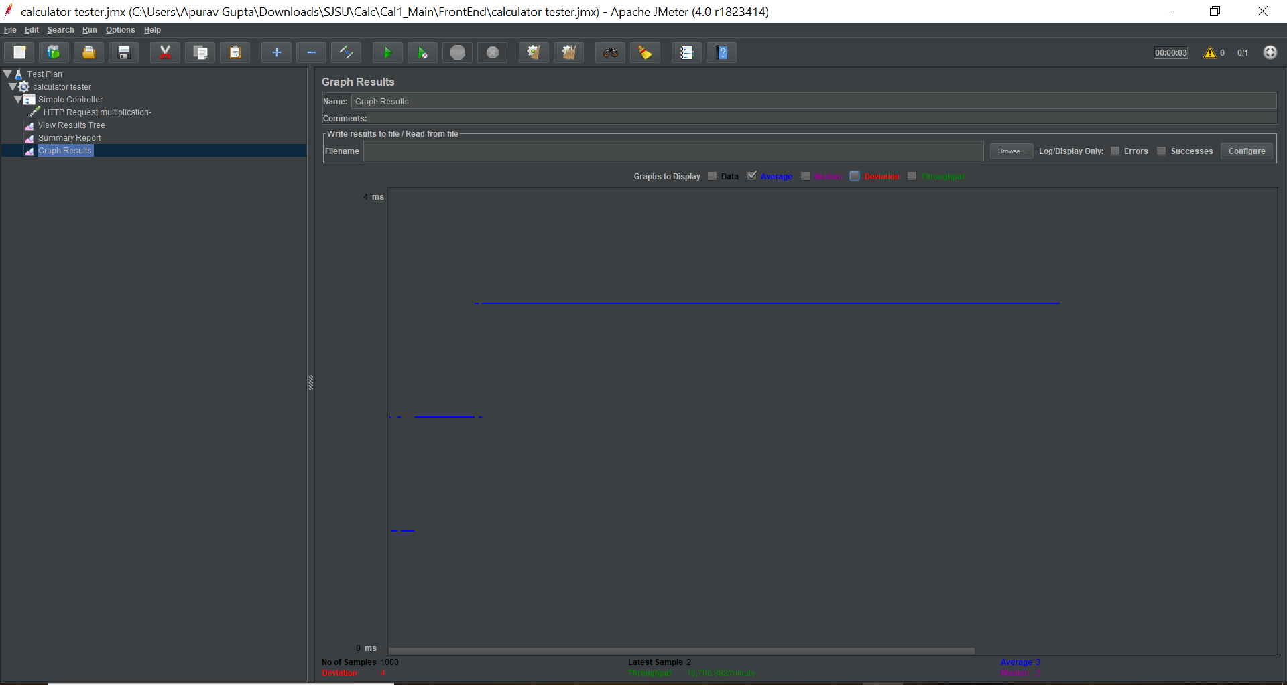

Summary Report:
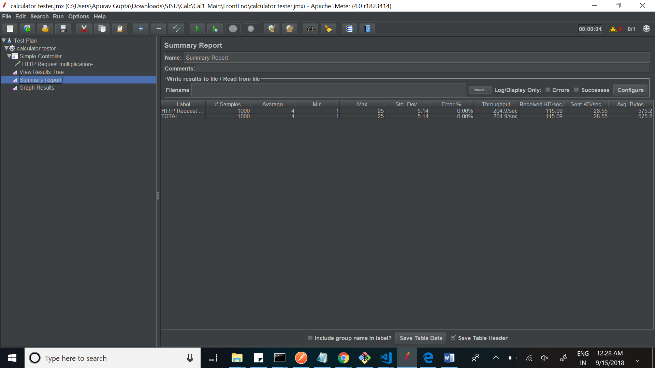
View Results Tree
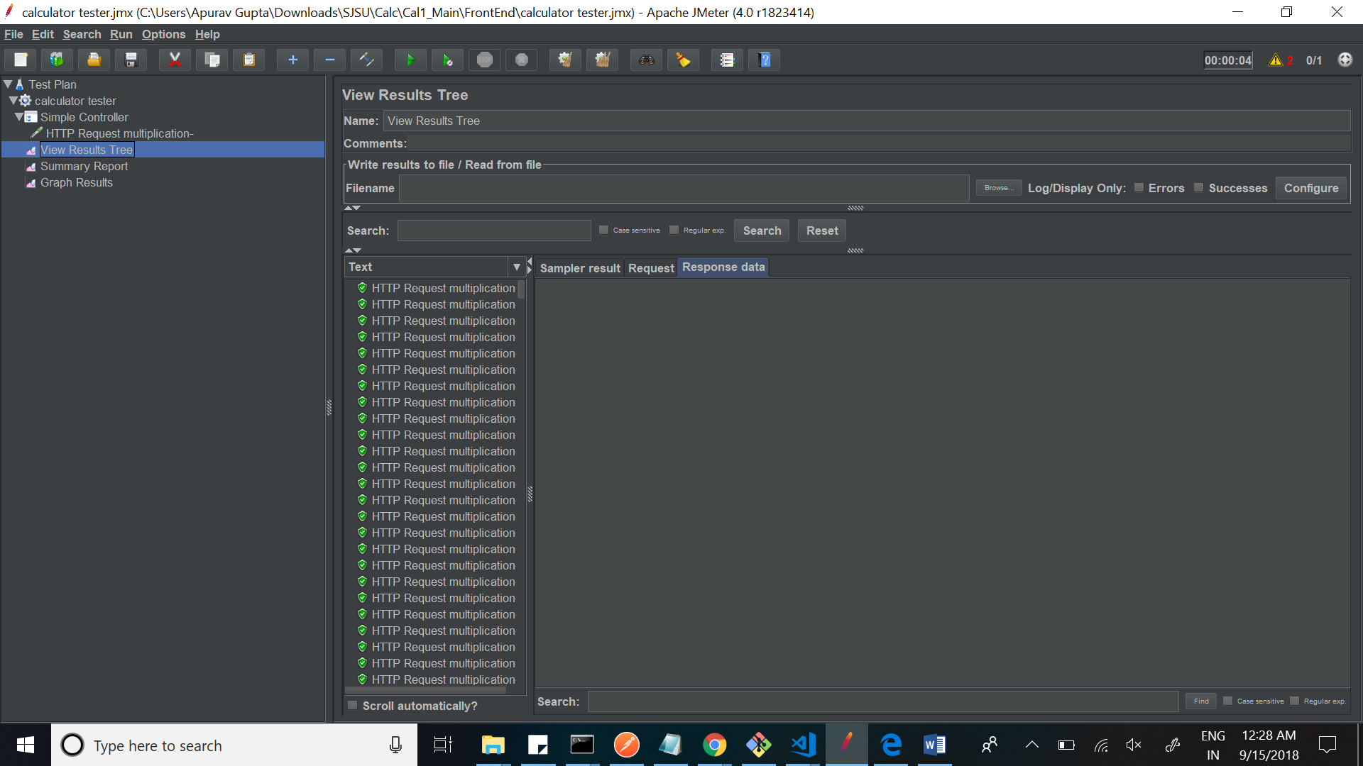

1 user 5000 requests
Graph Results:
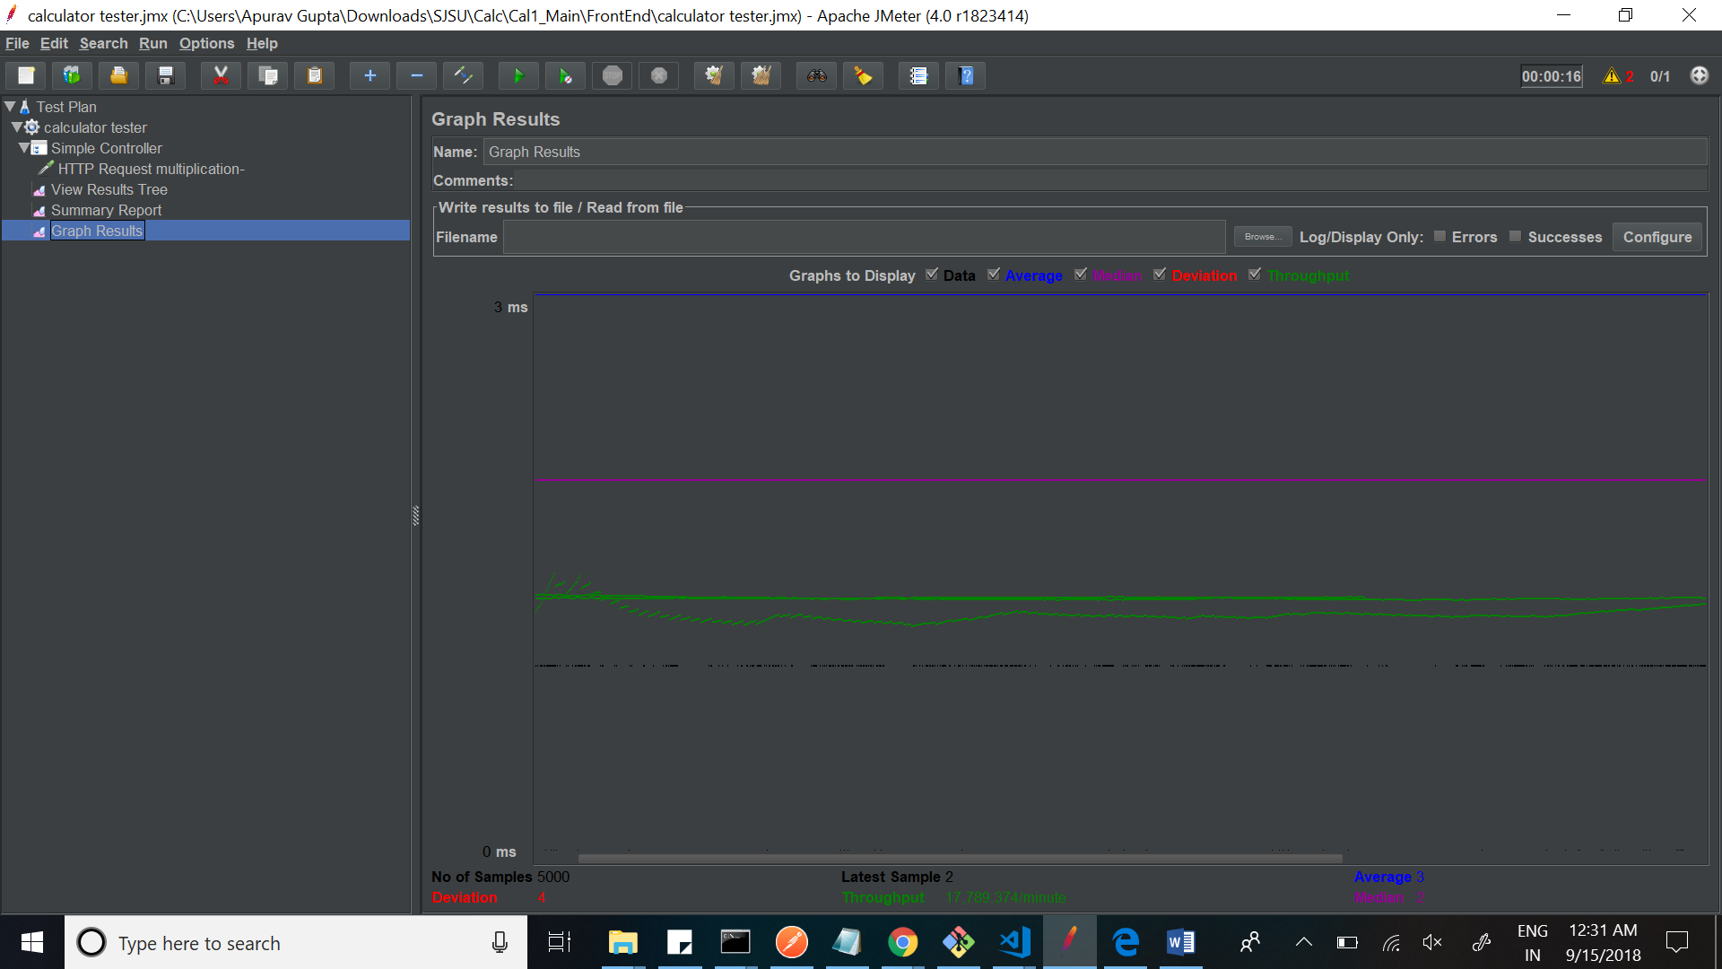
Average Time with deviation
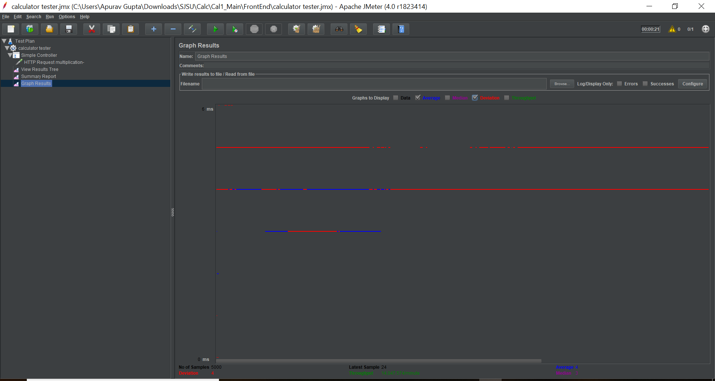

Average Time
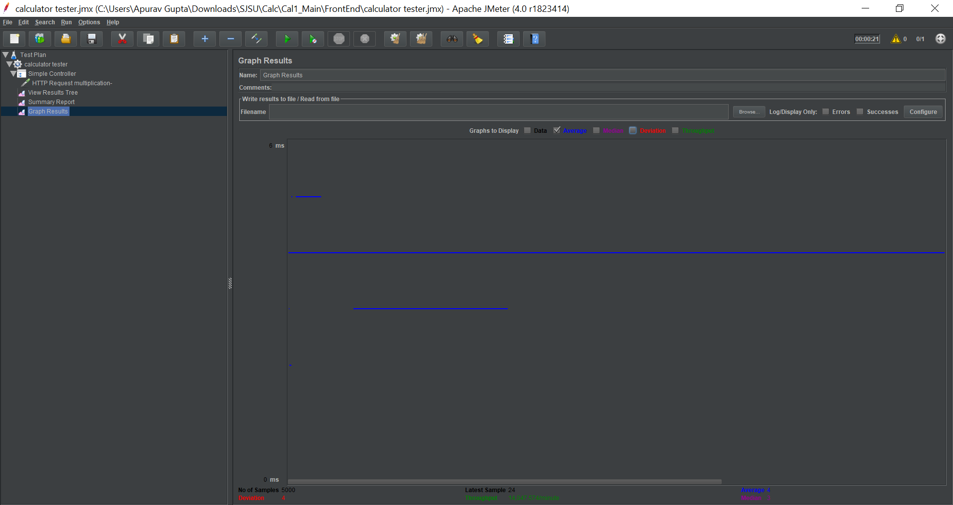
Summary Report:
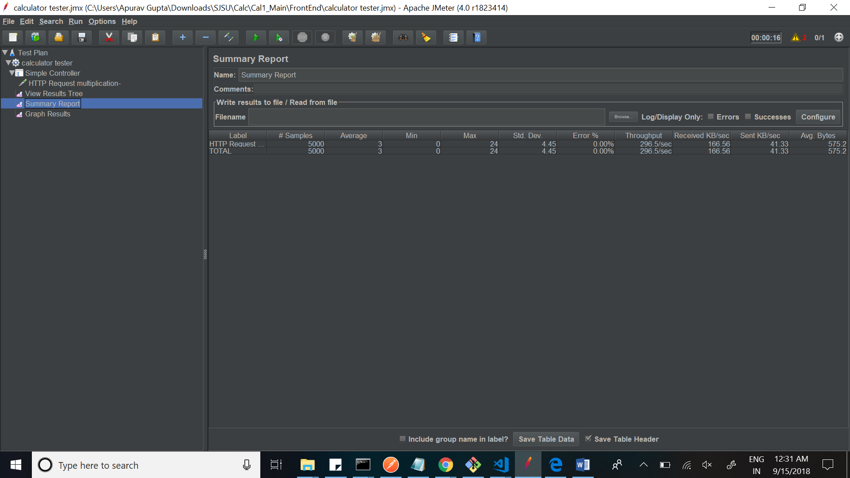

View Results Tree:
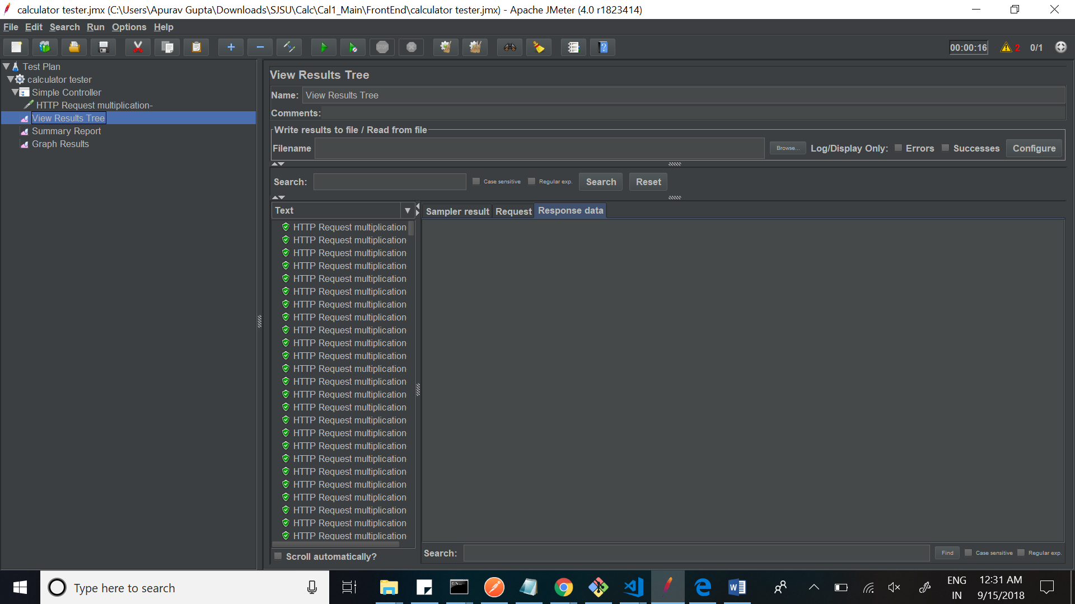

100 users 1000 requests
Graph results:
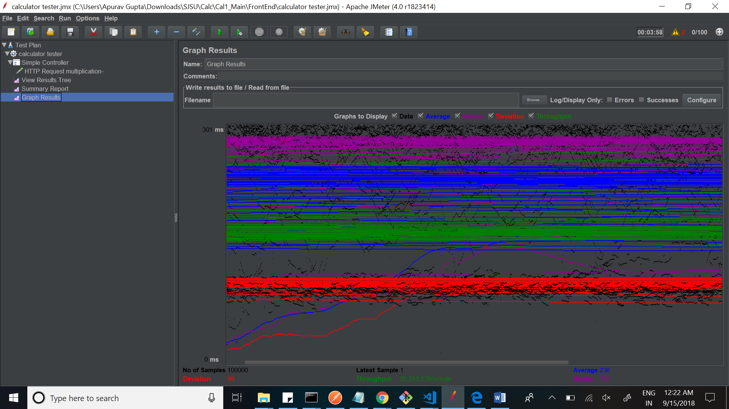
Average Time with Deviation:
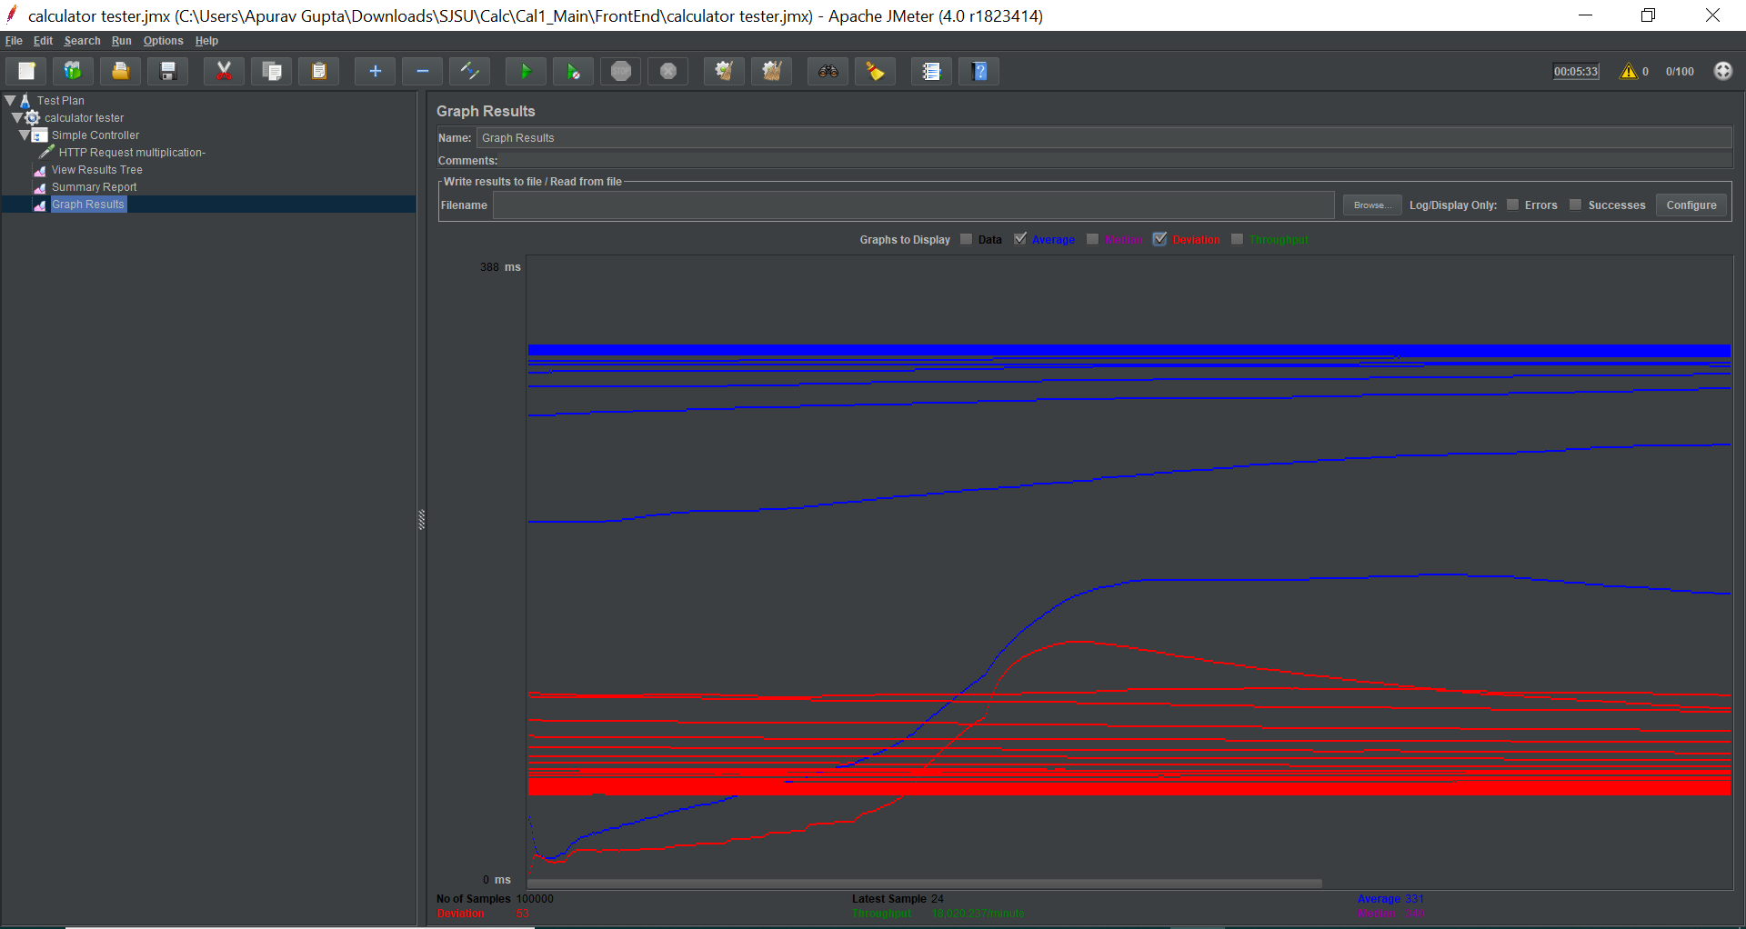
Average Time:
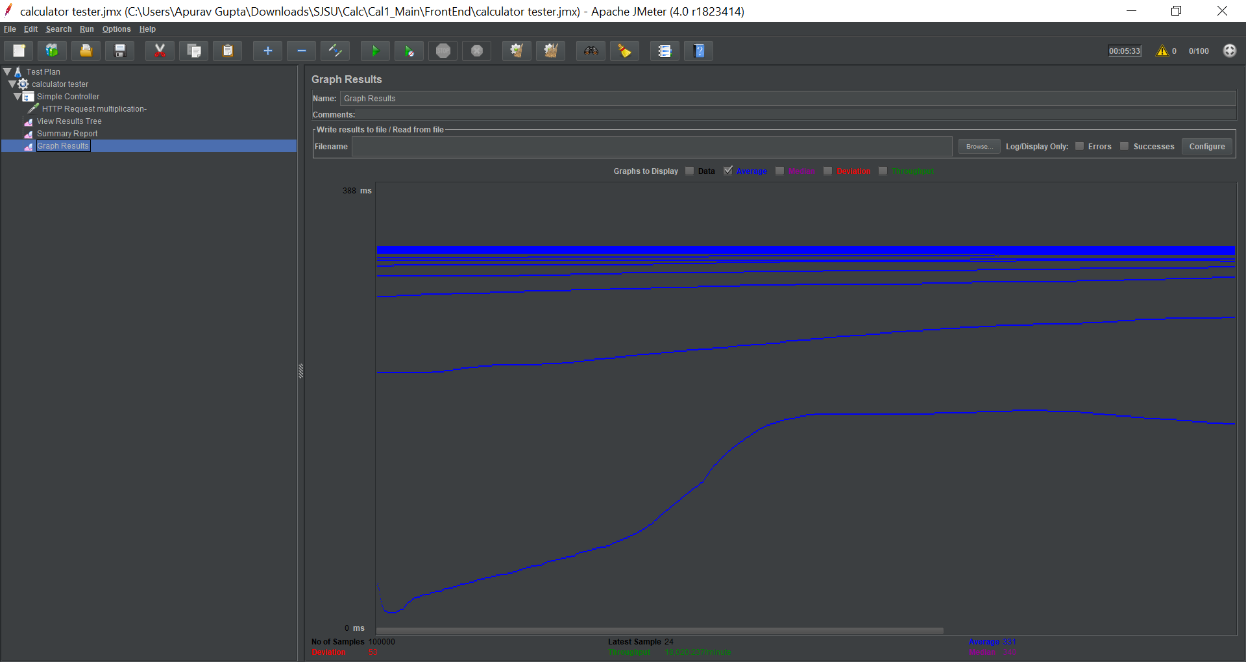

Summary Report:
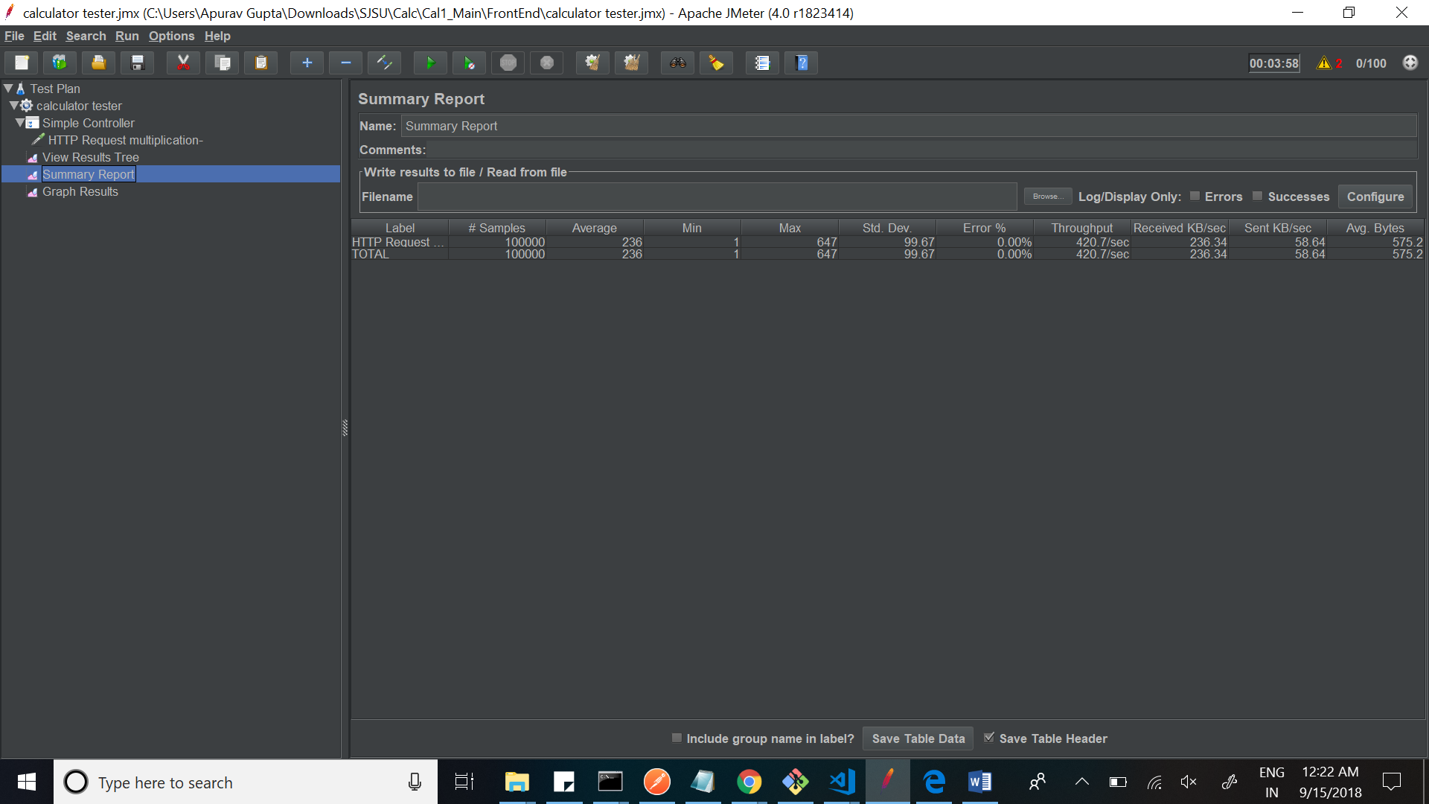

View Results Tree:

